DMX 512 wireless receiver/transmitter
Model：WD-200

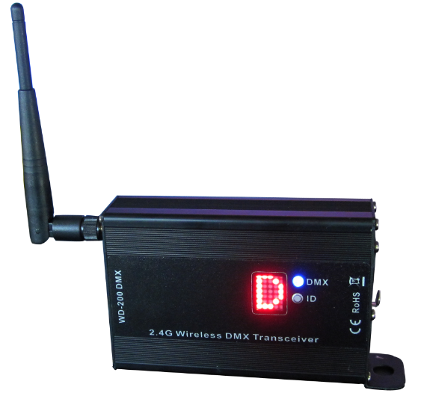

Please read carefully before using this fixture!

Introduction:
Thank you for purchasing our wireless series, These models is available for any stage lighting with DMX 512 Protocol. it can transmit standard DMX512 data between lights controllers wirelessly. The innovation of this product really brings us convenience for installation.
These products are adapted with 2.4G ISM frequency, which is global opening and without any limitations. It is high effective GFSK modulate, communication design ; 126 channels jumping frequency automatically，high anti-jamming ability.

Application:
Stage lighting、Disco hall、Large literature performance、Gymnasium lighting、Temporary stage performance 、City lighting system 、TV station 、Conference center 、 professional showplace、Topic park 、Bar lighting and so on.

Product Outline：
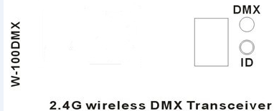

1：Indicator light of DMX Signal
2：ID Option Knob
3: LED Matrix Display for ID
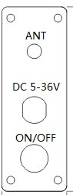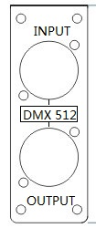
Side board
5: RF Antenna
6: Power Input
7: Power Switch
8: DMX Input Socket
9: DMX Output Socket
Features
- Model: WD-100
- 4 grade power rate output for option.
- 126 channels jumping frequency self-moving，self-moving to option non-interfere frequency section, ensuring communication is reliable.
- 16 groups ID coding for setting，User can use 16 groups individual wireless net without any interfere each other in the same place.
- Input voltage ：AC90-250V
- Communication distance：500M（visible distance）
- Working frequency：2.4G ISM,126 channels
- Max transmitting power rate：20dBm
- Receive sensitive：-94dBm
- DMX single terminal：3PIN male-female socket
Operation:
- RF frequency- - - - - - - - - - - - - - - - - - 2. 400-2. 525 G，Total 126 channels
- Transmitting power rate- - - - - - “0”=2dBm “1”=8dBm “2”=14dBm “3”=20dBm，Press “PA” for setting
- ID Code- - - -“0-F” 16 groups ID coding，press “ID” for setting，Please set the same ID for Transmitter and Receiver for DMX connecting.

Connecting Scheme：
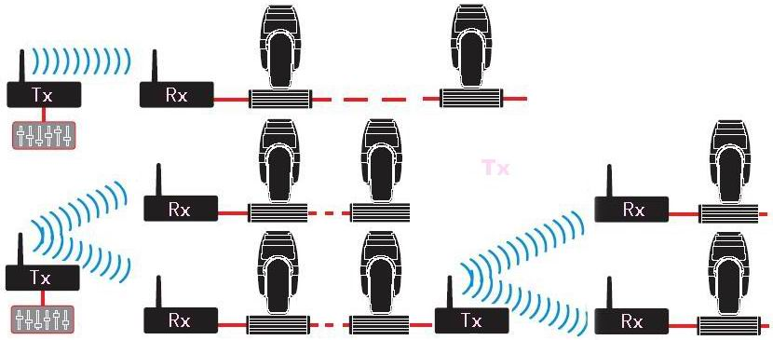

Establishing Communication：
      - Power on
      - Press “PA” to set transmitting power rate value， then press “ID” to set the receiver / transmitter with same ID. Please pay more attention, it is very important to set different ID value for different group of Wireless net.
      - When T&R have good communication with each other, Rxd Indicator LED will flash with fast speed.
      - Done.
Caution:
- Indoor use only.
- 1 year warranty
- The working condition should be under temperature -20°C~+45°C，10%～90%RH.

