D M X 512 w ire less
Receiver/Transmitter
M o d e l：W D -800

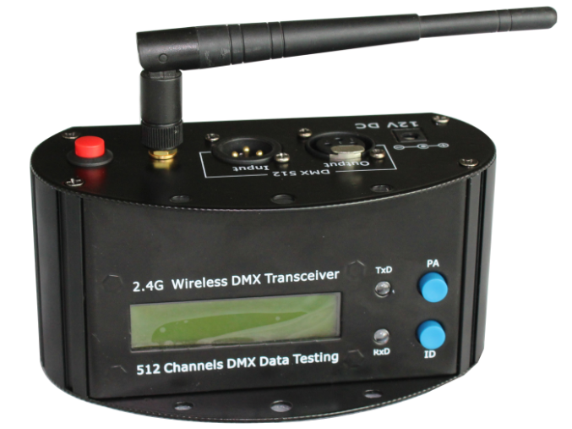

Please read carefully before using this fixture!

Introduction:
Thank you for purchasing our wireless series, These models is available for any stage lighting with DMX 512 Protocol. it can transmit standard DMX512 data between lights controllers wirelessly. The innovation of this product really brings us convenience for installation.
These products are adapted with 2.4G ISM frequency, which is global opening and without any limitations. It is high effective GFSK modulate, communication design ; 126 channels jumping frequency automatically，high anti-jamming ability.
Application:
Stage lighting、Disco hall、Large literature performance、Gymnasium lighting、Temporary stage performance 、City lighting system 、TV station 、Conference center 、 professional showplace、Topic park 、Bar lighting and so on.

PRODUCT OUTLINE:
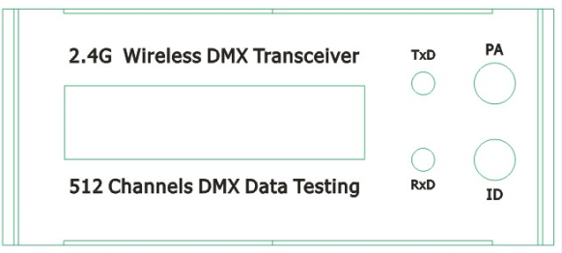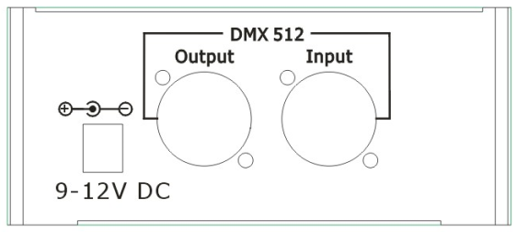
1：LCD display
2：Indicator light of receiver
3：Indicator light of transmitter
4： Setting knob of transmitting power rate
5：ID Option Knob
<NOTE: When the R & T is well connected. Red & Blue LED will flash with fast speed.>
6 : Power supply input jacket
7 : DMX Output Socket
8 : DMX Input Socket
Fea tu re s
1. Model: WD-800
2. 2*16 LCD display
3. 4 grade power rate output for option.
4. 126 channels jumping frequency self-moving，self-moving to option non-interfere frequency section, ensuring communication is reliable.
5. 16 groups ID coding for setting，User can use 16 groups individual wireless net without any interfere each other in the same place.
6. Input voltage ：AC90-250V
7. Communication distance：500M（visible distance）
8. Working frequency：2.4G ISM,126 channels
9. Max transmitting power rate：20dBm
10. Receive sensitive：-94dBm
11. DMX single terminal：3PIN male-female socket

O pe ra tion :

S tan db y M od e
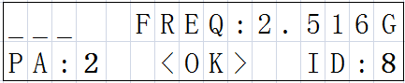
R ec e iv ing M od e
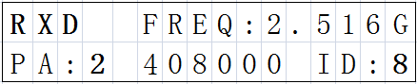
Trans m itting M od e
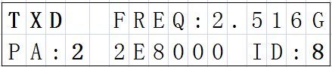
1. LCD display- - - - - - - - - - - - - - - - - - - - Include working condition、RF frequency, transmitting power rate, Self-testing Data, ID code.
2. RF frequency- - - - - - - - - - - - - - - - - - 2. 400-2. 525 G，Total 126 channels
3. Transmitting power rate- - - - - - “0”=2dBm “1”=8dBm “2”=14dBm “3”=20dBm，Press “PA” for setting
4. ID Code- - - -“0-F” 16 groups ID coding，press “ID” for setting，Please set the same ID for Transmitter and Receiver for DMX connecting.
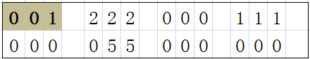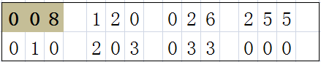
5. DMX testing data display. Press “PA” & “ID” at the same time. You will see this page for DMX transmitting data. Each page displays the data for 7 channels. Total 512 channels. For example: Page 1: 1-7ch, Page 2: 8-14ch. Page 73: 506- 511ch, Page 74: 512ch Etc.
C on nec ting S c he m e ：
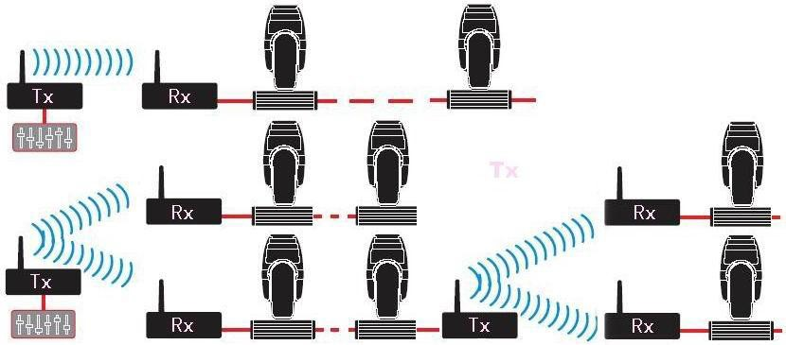
E s tab lis h ing C o mm un ic a tion ：
1. Power on
2. Press “PA” to set transmitting power rate value， then press “ID” to set the receiver / transmitter with same ID. Please pay more attention, it is very important to set different ID value for different group of Wireless net.
3. This equipment start to choose non-interfere frequency section for transmitting signal data after received DMX signal data，receiver start to change communicate frequency section，then Indicator lights of receiver and transmitter will flash at same time, till received correct ID value.
4. Done
Caution:
 Indoor use only.
 1 year warranty
 The working condition should be under temperature -20°C~+45°C，10%～90%RH.

